🟢 Q1
Write a C program to perform linear search and return the index of the first occurrence of a given element.
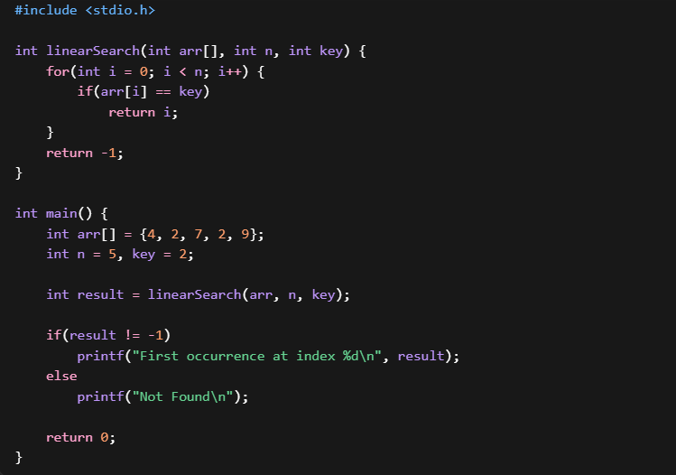

🟢 Q2
Modify linear search to return all occurrences of a given element.
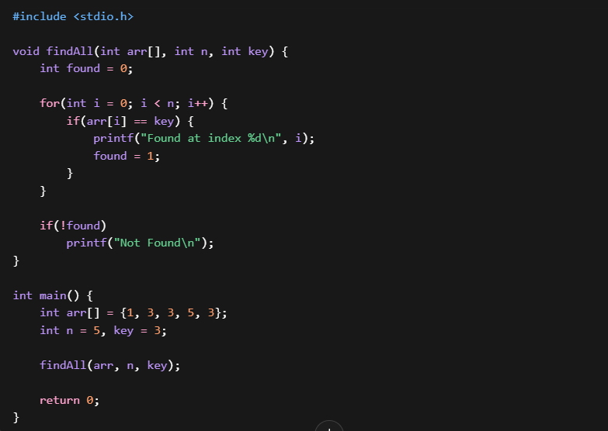

🟢 Q3
Write a C program to check if an element exists in an array using linear search (return true/false).
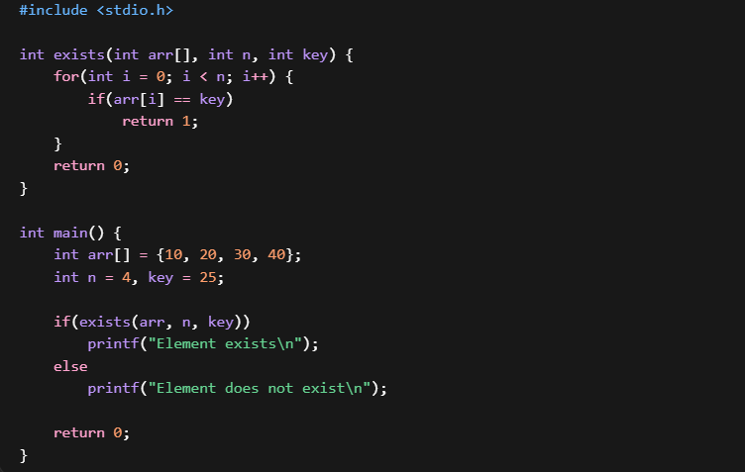

🟢 Q4
Count the number of comparisons made during a linear search.

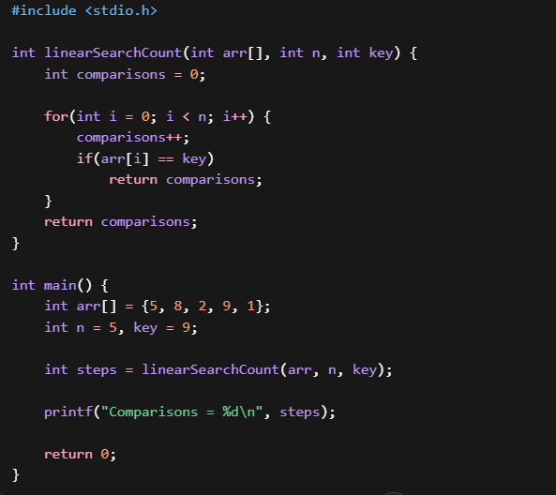

🟢 Q5
Search for an element in an unsorted array and return the last occurrence index.
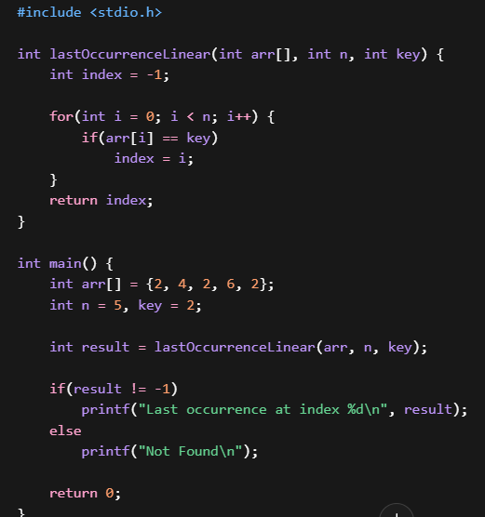

🔵 Q6
Write a C function to perform iterative binary search.
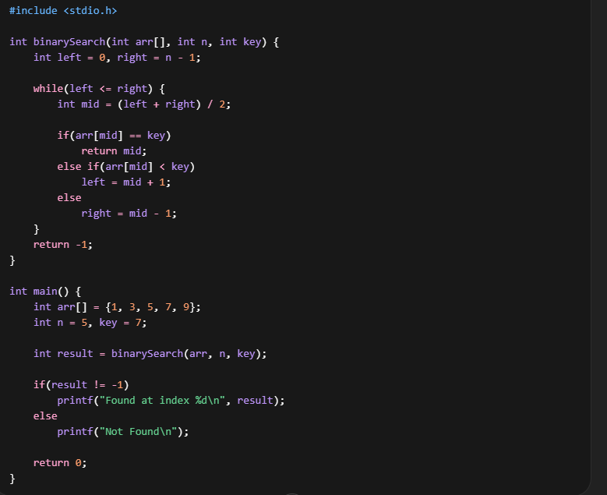

🔵 Q7
Write a recursive binary search function.

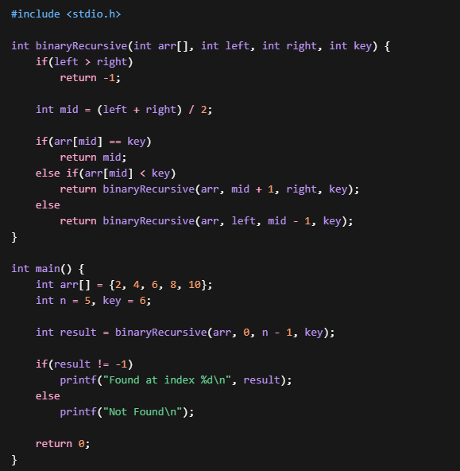

🔵 Q8
Modify binary search to count number of steps (iterations).

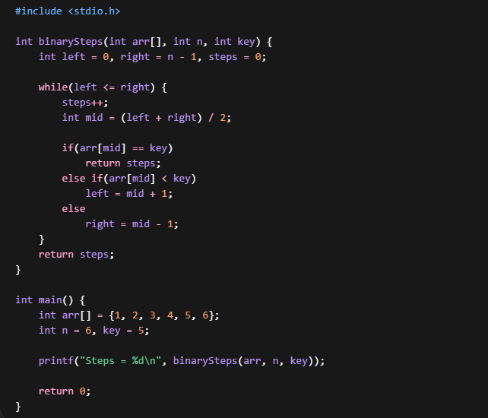

🔵 Q9
Find the first occurrence of an element using binary search.

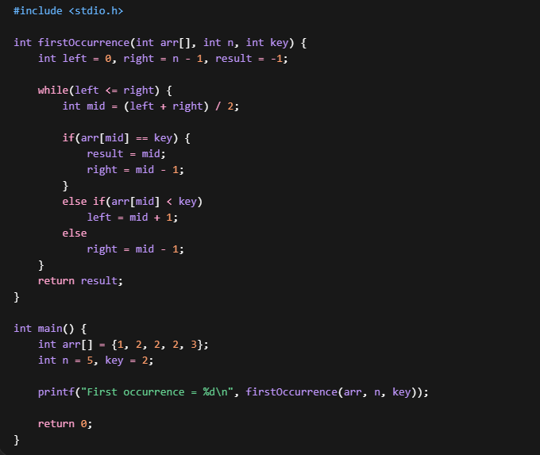

🔵 Q10
Find the last occurrence of an element using binary search.

